CCNA Assignment

**Module – 1**

* Explain is the OSI reference model?

OSI reference model is a 7-layer framework for computer networks :

1. Physical Layer
2. Data Link Layer
3. Network Layer
4. Transport Layer
5. Session Layer
6. Presentation Layer
7. Application Layer

* What is a Network?

A group of computers which are connected to each other for the purpose of sharing

their resources is called computer network.

* What are Routers?

Router is a network device which is used to connect different networks.

* Explain Encapsulation.

Wrapping data in multiple layers for secure transmission across networks.

* Peer-to-Peer Communication.

Direct communication between two devices (peers) without a central server, allowing them to share resources and exchange data.

* What is TCP and UDP?

TCP (Transmission Control Protocol) and UDP (User Datagram Protocol) are two transport layer protocols.

**TCP : -** Connection-oriented, reliable, and error checked. Ensures data is delivered in the correct order.

**UDP : -** Connectionless, best effort, and faster. Does not guarantee delivery or order.

* What is Internetwork Operating System software?

IOS software is a type of network operating system that manages and controls data communication between multiple networks, such as routers and switches.

* Explain LAN and draw any example.

LAN (Local Area Network) is a computer network that spans a small geographic area, such as a home, office building, or campus. It connects devices (computers, printers, servers) to share resources, exchange data, and communicate.

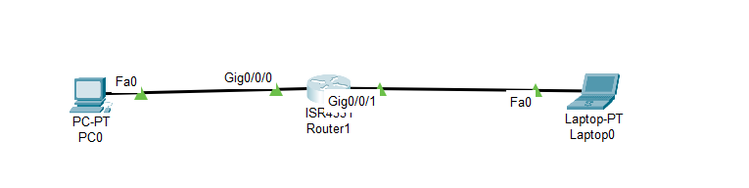

* Explain Network Device - Router Switch and Hub.

**Router :** A networking device that connects multiple networks together, directing traffic and forwarding data packets between them.

**Switch :** a networking device that connects multiple devices within a network, forwarding data packets between them based on their MAC addresses.

**Hub :** A simple networking device that connects multiple devices, repeating incoming data to all connected devices, without filtering or directing traffic.

* Describe Router and switch connection in LAN.

The router connects to the switch, and the switch connects to the devices, allowing them to access the internet and communicate with each other.

* Types of Cable - explain types of Ethernets and speed.

Types of cables are as below

Twisted Pair cable

Coaxial cable

Fiber optic cable

HDMI cable

USB cable

Ethernet cable (RJ-45)

Types of Ethernet cables are 568 A and 568 B.

Speed of Ethernets are

CAT 1 : 2 Mbps

CAT 2 : 4 Mbps

CAT 3 : 10 Mbps Ethernet cable

CAT 4 : 16 Mbps

CAT 5E : 100 Mbps ( Fast Ethernet cable)

CAT 6 : 1 Gbps ( Gigabit Ethernet Cable)

CAT 6E: 10 Gbps (10 Gigabit Ethernet Cable)

* Explain TCP/IP -List of Protocol and port Number.

Transmission Control Protocol/Internet Protocol is a suite of communication protocols that enables devices to communicate over the internet. It consists of four layers:

1. Application Layer (HTTP, FTP, etc.)

2. Transport Layer (TCP, UDP)

3. Internet Layer (IP)

4. Network Access Layer (Ethernet, Wi-Fi)

list of common protocols and their port numbers:

1. HTTP - 80

2. FTP - 21

3. SMTP -25

4. pop 3 - 110

5. TFTP - 69

6. DNS - 53

7. DHCP - 67/68

8. NTP -123

9. RDP – 3389

10. ARP

11. RARP

12. IP

13. Telnet – 23

14. TCP – 17

15. UDP – 6

16. SNMP – 161

* Explain Node(backbone) and Physical layer.

A node is a connection point in a network, such as a computer, router or switch. A backbone is a high-speed network that connects multiple nodes or networks together.

The Physical Layer defines the physical means of transmitting data between devices, including :

Cables (Ethernet, Fiber optic)

Wireless transmission (Wi-Fi, Bluetooth)

Network topology (Bus, Star, Mesh)